Week 6 Direct Independent Study Progress

* **Topic Covering**: Al-Powered Phishing Detection Using NLP & Explainable Al.

# **Data Preprocessing**

* ***Focus:***
  + ***Working on code as SHAP generation runs into errors. Plots are also not being generated.***
  + ***Update:*** 
    - ***Confusion Matrix, Top features, & ROC plots are successfully generated.***
    - ***LIME Explanation on sample emails is also generated.***

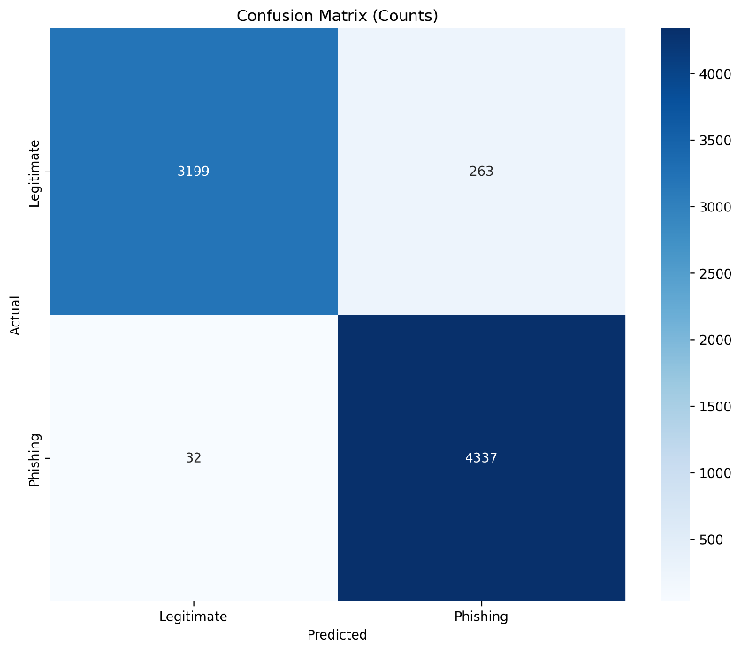

Confusion Matrix of emails ran

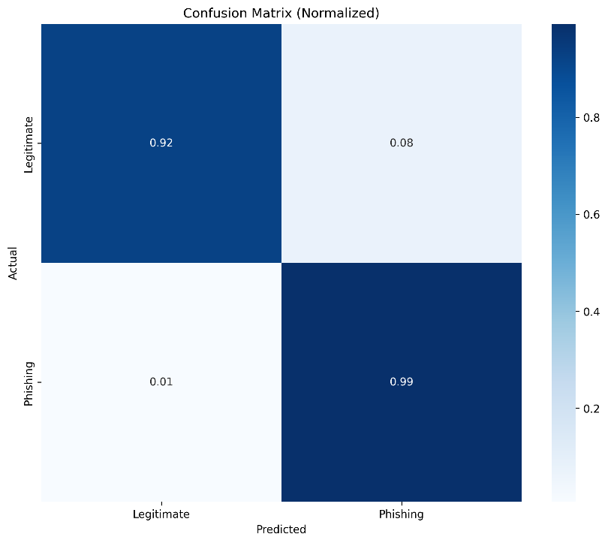

Confusion Matrix Normalized

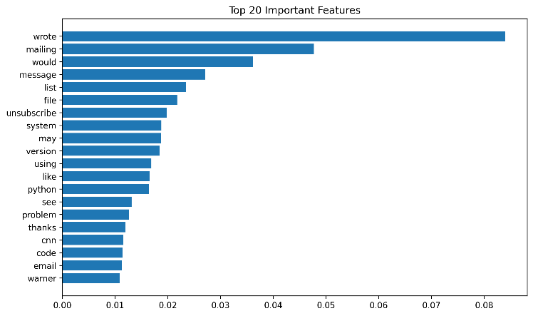

Top Features Found from email analysis

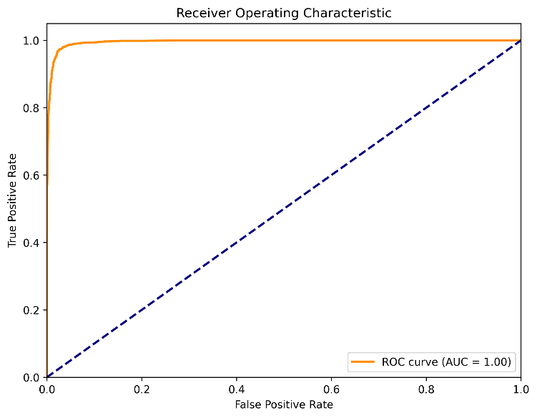

ROC Plot

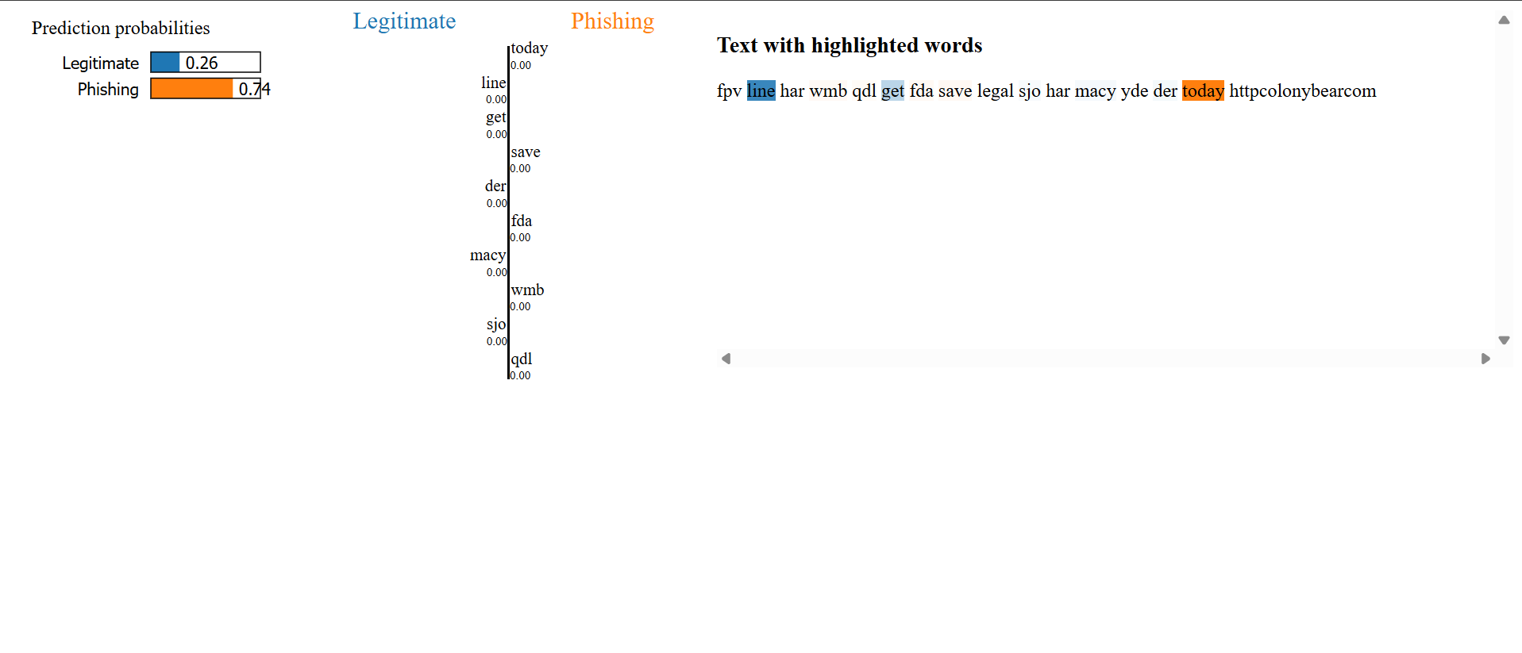

Sample Email of LIME Prediction and Explanation